Student Name: **Hongyao Tao (001067209)**

**INFO 6205**

**Program Structures & Algorithms**

**Spring 2021**

**Assignment No.1**

* The relationship between *d*and*n*

**d=n^0.4903**

* **Evidence** to support that relationship

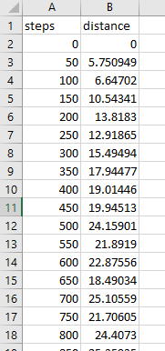 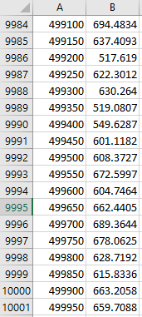

**Figure 1. The data of steps and distance from random walk simulation**

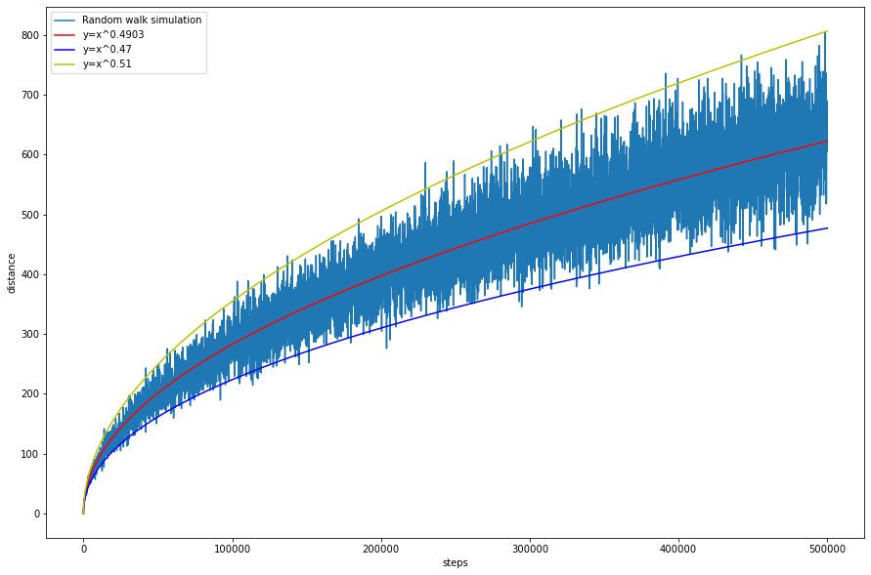

**Figure 2. The line graph of random walk simulation**

* *RandomWalk.java*

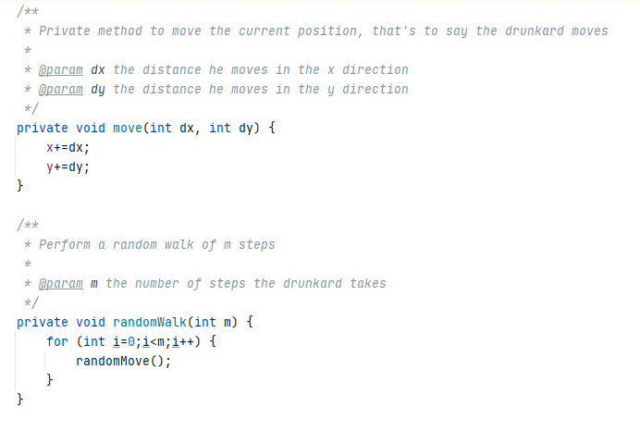

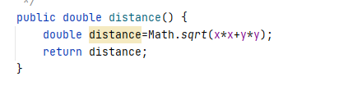

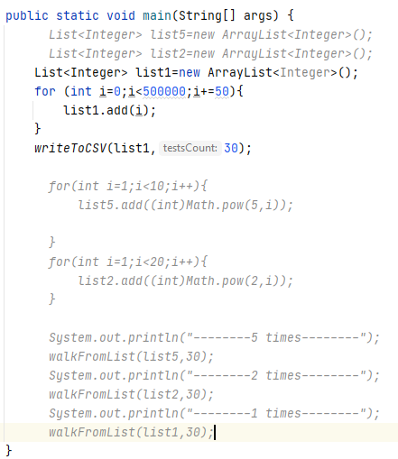

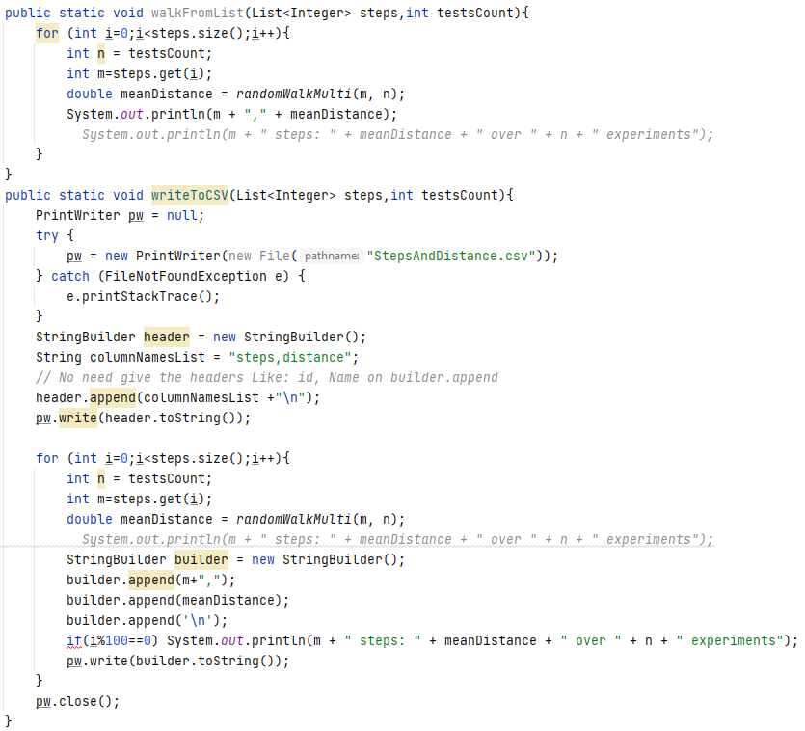

* A **screen shot** of the unit tests all passing

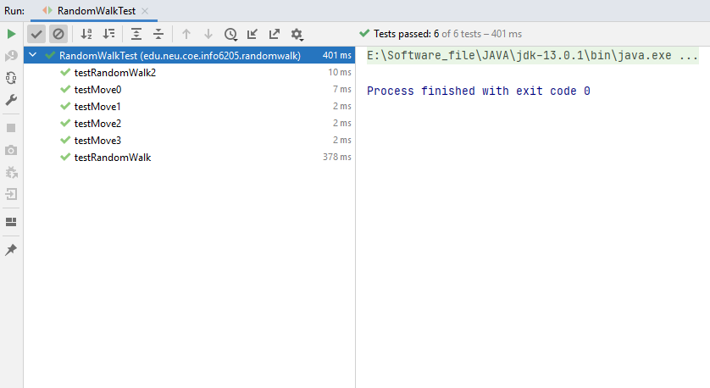

**Figure 3. The unit test result**

The result of RandomWalkTest showed that RandomWalk.java code is correct and passed all unites tests.